**[The-Battle-of-Neighborhoods](https://mmahrouss.github.io/The-Battle-of-Neighborhoods/)**

**Where to Go When You Want to Eat AFRICAN CUISINE ?**

*Data Science Capstone - IBM Data Science Professional Certificate on Coursera*

**Introduction**

Let’s say you have never been to the US and you want to have only African cuisine while you are there. So you want to go to a place with a high density of African cuisine places around you. The problem we aim to solve is to analyze the African cuisine’ locations in the major US cities and find the best place for our tourist so that he can have a good African dish. Our main target are tourists with a taste of African cuisine

**Data section**

I will make use of the FourSquare API to collect data about locations of African cuisine in 4 major US cities which are: New York,NY, San Francisco, CA, Boston, MA and Chicago,IL. These are one of the most populated US cities and I am hopeful that they will contain the best African cuisine in the US.

**Methodology**

The main target here is to asses which city would have the highest African cuisine density. I used the Four Square API through the venues channel. I used the near query to get venues in the cities. Also, I use the CategoryID to set it to show only African cuisine.Foursquare limits us to maximum of 100 venues per query.

Moreover, I repeated this request for the 4 studied cities and got their top 100 venues. I saved the name and coordinate data only from the result and plotted them on the map for visual inspection.

Next, to get an indicator of the density of African cuisine, I calculated a center coordinate of the venues to get the mean longitude and latitude values. Then I calculated the mean of the Euclidean distance from each venue to the mean coordinates. That was my indicator; mean distance to the mean coordinate.

**Results**

For our initial visual inspection we see that they all have multiple African cuisine and often more than Foursquare would like to supply us. The following here are the pictures of the geoplot generated with folium:

**New York:** 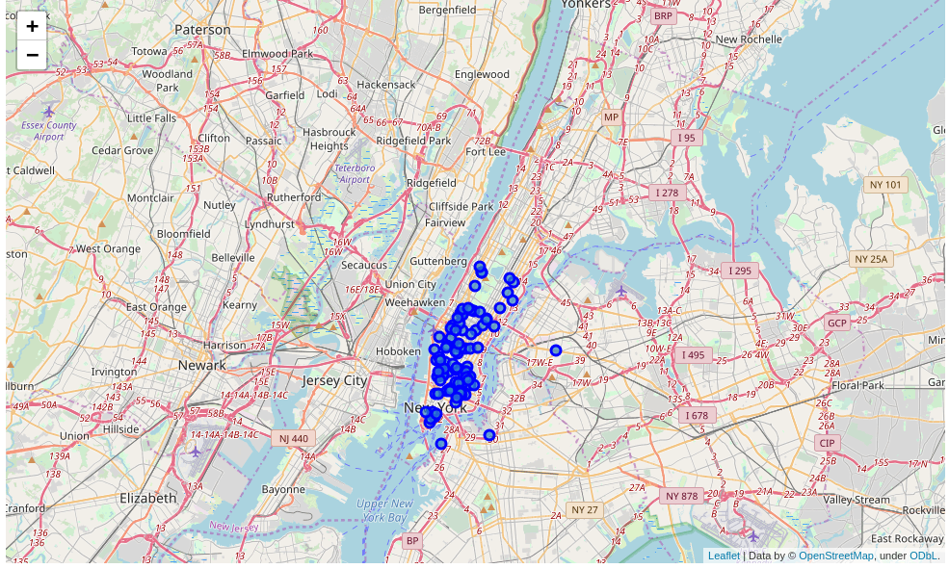

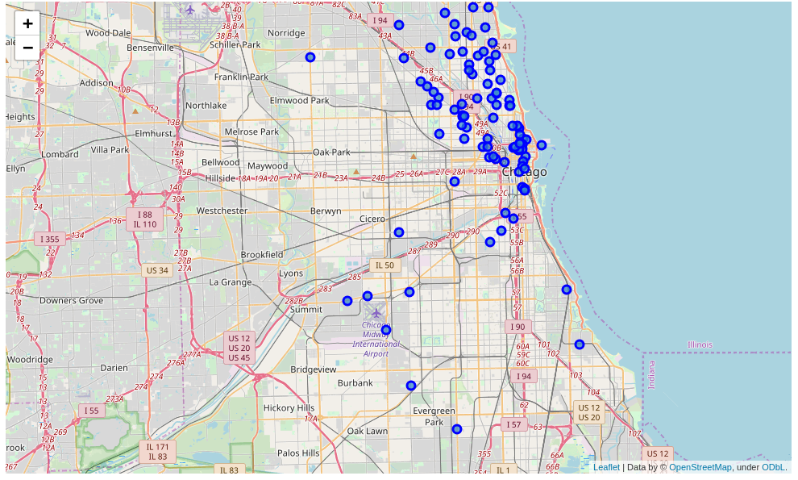

**Chicago:**

**San Francisco:** 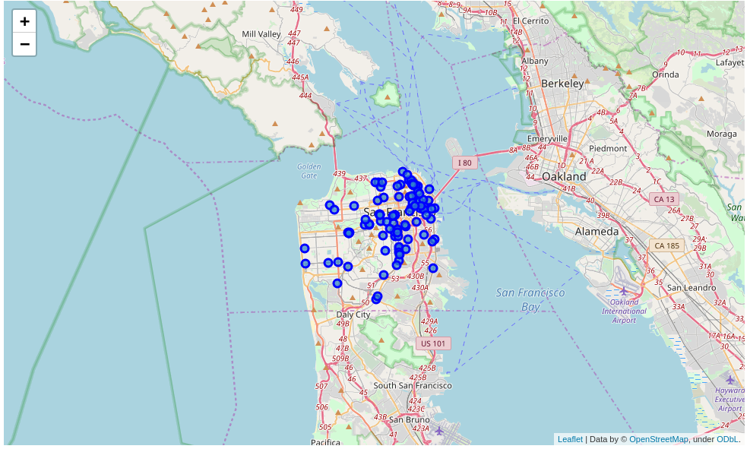

**Boston:**

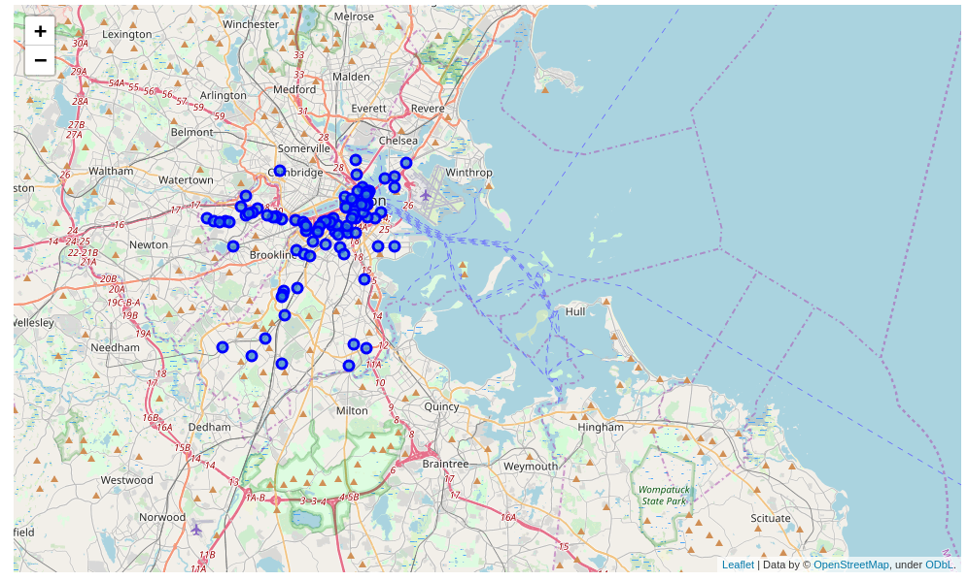

Upon First inspection we see that New York and San Francisco are the most densely cities. In the next phase we Calculate the Mean coordinate and the mean distance to mean coordinate(MDMC). We represent the mean coordinate with a big green circle and distances with green lines

MDMC: 0.021556

**New York:**

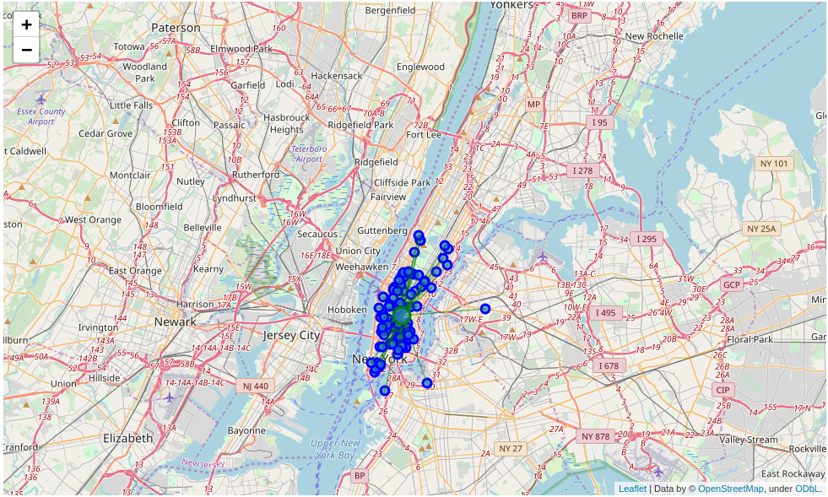

**Chicago:**

MDMC: 0.052805

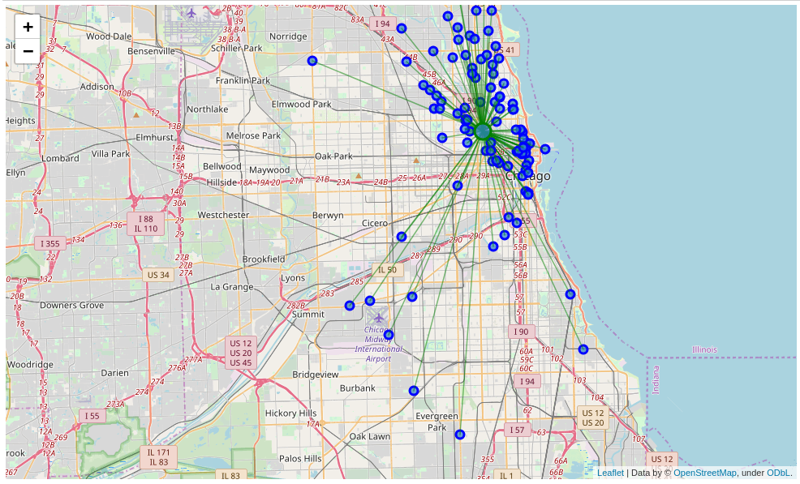

**San Francisco:**

MDMC: 0.028633

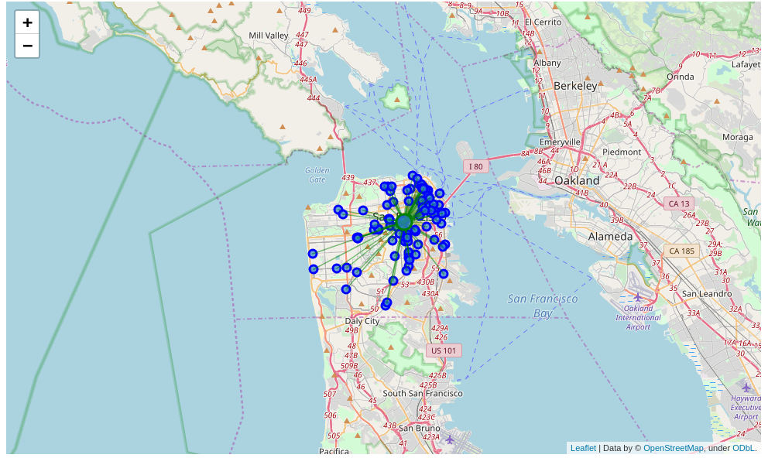

**Jersey City:**

MDMC: 0.029950

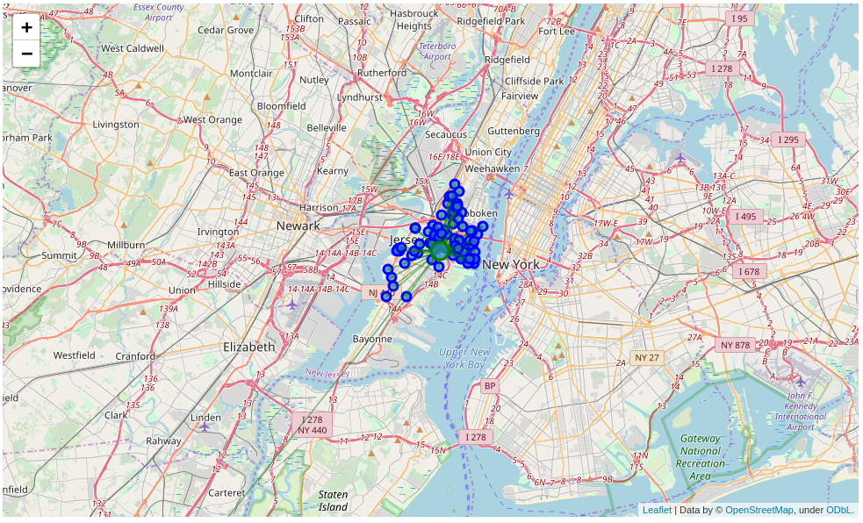

**Boston:**

MDMC: 0.035126

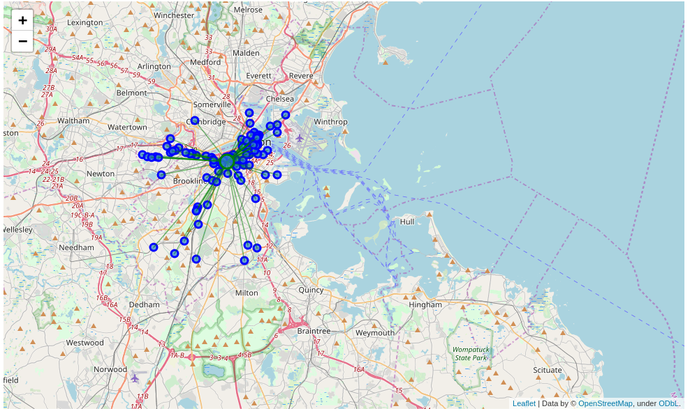

Therefore our results are :

1. New York
2. San Francisco
3. Chicago
4. boston

**Conclusion:**

Now there is no doubt that New York is the best place to try many Pizza Places in the US. Also, if our tourist is done with all the New York pizza places he can cross to Jersey City and enjoy 99 more.

Also, we would recommend that our tourist book a hotel close to the mean coordinate.